Laser Hygrometer

Operations Guide

Model: LH-1370TO-CVI

Rev. A.1, May 2011

Port City Instruments, LLC

301-C N. Green Meadows Drive
Wilmington, NC 28405
Tel: 910-622-6486 ● Fax: 910-798-2048
Table of Contents

Introduction 3

Specifications and Initial Set Up 5

Theory of Operation 5

Serial Data Output Format 7

Software Operation 8

PC104 Electronics 13

Troubleshooting 14

Contact Information 15

Appendix A - Power Connector Pinout

Appendix B - Humidity Conversion Equations

Introduction
The hygrometer decribed in this manual was designed as a direct replacement for an earlier design that used a low-power microcontroller, and which was tailored for measurements with a counter-flow virtual impactor (CVI). As such, it operates using an identical input power connector (+5 VDC and +28 VDC) and an identical data output connector (9-pin D for RS232C), and accomodates the large enhancments in water vapor produced by the CVI. It begins a control program and produces output on the serial port at power up, with no further action needed by the user.

Water vapor is measured using near-infrared laser absorption spectroscopy and a combination of second harmonic detection (at low H₂O levels) and integration of the direct absorption spectrum (at medium to high H₂O levels). The hygrometer utilizes a near-infrared (~1371 nm) tunable diode laser whose output beam is directed along a folded 13.8 cm optical path. The laser wavelength is swept repetitively across a single rovibrational line of the target molecule (H₂O in this case) to record a high resolution spectrum. Water vapor volume mixing ratio can be determined using the Beer-Lambert law and laboratory calibrations of the second harmonic signal channel response. A more detailed description is given in the Theory of Operation section later in this guide. Detection range for water vapor is from approximately 50,000 parts per million by volume (ppmv) down to approximately 50 ppmv, over a total pressure range of 200 to 1100 mbar.

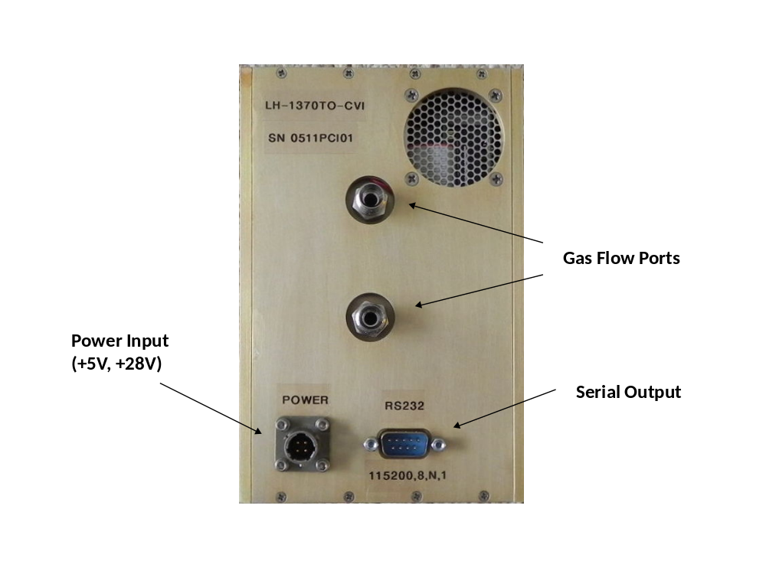

Specifications and Initial Set Up

Table 1. Basic Specifications
Model | LH-1370TO-CVI
Measurement Range (H₂O) | 50- 50,000 ppmV (parts per million by volume)
Measurement Technique | Second harmonic detection + direct absorption
Time Response | Nominally 2.7 Hz (adjustable over small range)
Output Formats | Serial (115.2 KB, 8 bits, 1 stop, no parity)
Power Requirements | 28 VDC @ 0.72A, 5 VDC @ 3.1A
Dimensions | 6.50" Height x 4.25" Width x 4.375" Depth
Weight | 4 lbs (1.8 kg)

The instrument electronics and thermostatted optical absorption cell are contained in a custom aluminum enclosure designed for compatibility with a previous design used for CVI water vapor sensors.

+28 VDC and +5 VDC are supplied via a 4-pin twist-lock BendixTM connector located on the front panel of the enclosure. Serial output is provided via a standard 9-pin "D" connector adjacent to the power connector. Pinouts for the power connector is given in Appendix A. Gas inlet and outlet connections are via 1/4" swagelock fittings on the front panel. Flow direction is irrelevant to the measurement so the inlet / outlet designations can be chosen based on convenience.

Theory of Operation
Water vapor absorbs light at many wavelengths throughout the electromagnetic spectrum from the ultraviolet wavelength region to the microwave region. The development of the telecom optical fiber infrastructure in the 1990s led to the availability of relatively low cost, single-frequency, continuously-tunable diode lasers that operate in the low-loss transmission region of optical fiber (1.3 - 1.6 microns). Water vapor has several combination bands (one quantum of vibration excited in two different fundamental vibrational modes) and overtone bands (two or more quanta of vibration excited in one fundamental vibrational mode) in this near-infrared region centered near 1380 nm. A detailed discussion of high-resolution rovibrational spectroscopy is outside of the scope of this operations guide, but a brief description of how the spectrometer works follows.

The 1380 nm band of water vapor consists of hundreds of individual vibration-rotation absorption lines of varying absorption strength. Any of these individual spectral lines could be used to monitor the concentration of water vapor according to the Beer-Lambert law:

ρ = -ln(τ) / [k(ν) x L] (5)

where ρ is the concentration of water vapor in molecules per cm³, τ is the observed transmission at the spectral line center wavelength, k(ν) is the absorption cross section in cm²/molecule, and L is the optical pathlength in cm. τ is equal to I/Io, where is Io is the transmission of laser light through the sample path at the spectral line center in the absence of any H₂O absorption, and I is the observed transmission at the center of the H₂O line when H₂O is present in the optical path. Therefore, if k(ν) and L are known, a measure of τ provides the H₂O concentration. An alternative way to write equation 5 is as follows:

ρ = ∫-ln(τ) / [S(T)) x L] (6)

where the spectral line is integrated to obtain its area, then divided by the molecular line strength times the optical absorption pathlength.

To obtain greater measurement sensitivity, second harmonic (2f) detection is utilized which allows absorption values (absorption, A = 1 - τ) as small as a few parts in 100,000 to be detected. This allows for extension of the dynamic range by typically a factor of 100 over conventional direct absorption spectroscopy. In addition, this technique removes the sloping baseline present on the direct transmission spectrum (see discussion below), it produces a zero-based detection method while direct transmission requires the measurement of small changes on a large background, and it moves detection to a high frequency regime minimizing 1/f noise. These are the primary advantages of 2f detection and why detection sensitivity is much higher than conventional direct transmission spectroscopy.

To implement 2f detection a small-amplitude sinusoidal waveform is added to the base laser current ramp, which places a small modulation on the laser wavelength (a diode laser is tuned in wavelength by changing either the temperature or the current ... we fix the laser temperature and change the laser wavelength by applying a sawtooth ramp to the laser current). Detection at twice this wavelength produces the 2f signal which appears qualitatively like the second derivative of the normal absorption line shape. Quantitatively, because the modulation amplitude placed on the laser wavelength is not small relative to the spectral line width, it is correctly described by the second harmonic in a full Fourier expression. Normalizing the 2f spectrum to the simultaneously-recorded laser power allows measurements to be made that are independent of the laser power level at the detector, and issues like misalignment, dirty optics, etc. do not impact the measurement until they result in laser power levels that are extremely low (few percent of the "clean optics" level).

For maximum sensitivity, it is always desirable to use the strongest spectral line possible as this produces the largest line center absorption value. For H₂O in the Earth's atmosphere, there are no other interfering absorbing molecules that can create absorption features of any measureable level (N₂ and O₂ have no infrared spectra, CO₂ has no detectable absorption lines near 1380 nm, and all other normal atmospheric gases either have extremely weak absorption bands in this region, or have no infrared bands at all (eg. Ar)). We use one of three isolated H₂O lines near 1371 nm, which are some of the strongest lines in the band and coincide with a standard telecom laser wavelength for course wavelength division multiplexing (CWDM) systems.

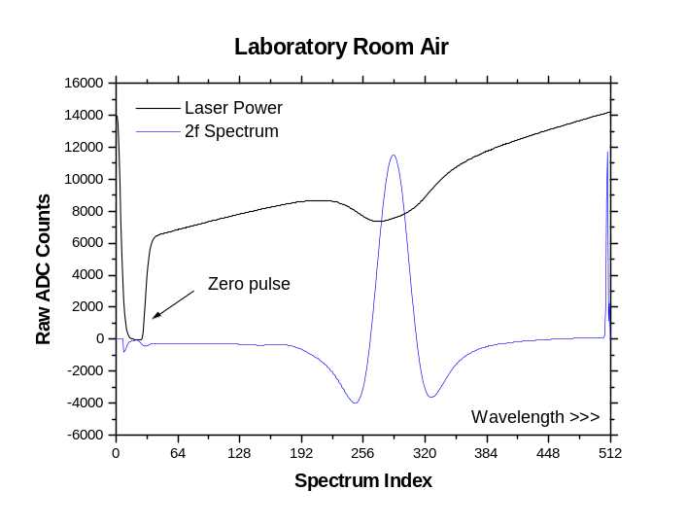
Figure 1 shows a pair of raw spectra from the short path channel recorded with normal room air in the sample cell. The laser power increases as the wavelength increases because laser power is proportional to laser current, and the laser output wavelength increases with increasing laser current. The H₂O line can be seen as a "dip" in the middle of the laser power spectrum (black trace), and it is broadened by the sinusoidal modulation needed for 2f detection. The 2f spectrum is also shown (blue trace) and its amplitude, normalized to the laser power at the spectral line center, is proportional to the H₂O concentration in the sample cell. Since molecular line strengths and line widths are dependent on temperature and pressure (because k(ν) is dependent on T and P), the software corrects for these effects using the measured sample cell temperature and pressure. To convert the measured H₂O parts per million by volume (ppmv) number to other units of humidity for the air outside the aircraft (eg. dew point) it is necessary to know the static air temperature and pressure (ppmv is conserved through P and T changes while units like RH and dew point are not).

Serial Data Output Format
The measured H₂O values and housekeeping diagnostics are output on a serial port located on the front panel of enclosure (115,200 baud, 8 bits, 1 stop bit, no parity). A null modem RS232 cable is required to receive the output data stream directly on a remote computer.

The serial port output is as follows (sample line from a Hyperterminal capture):
2.537 495.06 45.16 37.11 42.36 5494 10116 272 -4087 0.941 <CR><LF>
where the order of parameters, left to right, is:
1) H₂O value in g/m3
2) Sample cell pressure in mbar
3) Sample cell temperature in C
4) Enclosure inside air temperature in C
5) Laser assembly heatsink temperature in C
6) Raw peak-to-peak 2f signal counts
7) Raw laser power level at line center in counts
8) Position of the H₂O line within the 0-511 point scan range (used to monitor laser T stability)
9) Zero level out of DC (laser power) signal chain when laser is turned off
10) Tmod = Line center transmission value for target H₂O line (modulated … see notes below!)
11,12) Carriage Return + Linefeed to terminate each line
The C format specifier is:
"%7.3f %7.2f %6.2f %6.2f %6.2f %6u %6d %3d %6d %5.3f\r\n"

The best parameters to use for “health” monitoring are the laser power level (parameter 7 above) and the spectral line position (parameter 8 above). There is an intentional voltage offset on the laser power channel to optimize the A/D converter resolution. This offset corresponds to about negative 4000 A/D counts (eg. zero level in the above sample data line is -4087 counts). As long as the laser power counts are above about ~1000 there is sufficient power for measurements. Below this (ie. +1000 to -4000 counts) either the laser has become misaligned or the optics are dirty and should be cleaned.

Assuming the laser power level counts are greater than ~1000 counts, the next most important parameter to monitor is the spectral line position (parameter 8). This should fall within the range 250 – 300 at all times and indicates that the laser temperature controller is operating properly. The line position will typically wander around slowly by a few points as the ambient temperature around the sample cell changes, but should not be erratic or "jumpy."

Software Operation
The system software runs from an x86-compatible single board computer (Diamond Systems Helios 800 MHz CPU board with integrated analog I/O) booting embedded MS-DOS. There is a 2 MB solid-state storage device on the CPUI board that appears as drive A:, and a directory (A:\H2O) on this drive contains the control program (TDL1.EXE) and associated input files. A compact flash card (sent with an adapter) can be connected as well for additional storage, or to update the software. When this is connected the CPU board still boots from the A: drive, but the compact flash drive appears as drive C: BIOS settings can be altered to change the boot order if it is desirable to run only from the compact flash card. As shipped, this card is bootable and set up to run the same control program as on the A: drive. Some commands are described later in this section that can be used to start and stop the control program when a monitor and keyboard are connected for access to the operating system.

At power up the computer automatically executes a control program and provides the serial output described in the previous section. Standard VGA monitor (15-pin high density D-sub connector) and PS2 style keyboard connectors are initially connected to the CPU board and tied down in the PC104 box for initial testing. These cables, along with an IDE compact flash adapter cables, can be removed if desired once the system configuration is fixed.

When the control program executes, the initialization files are read in and a short (10s) delay is implemented for laser stabilization before serial output begins. There is a primary configuration file that the control program uses to define the laser scan current range and 2f modulation amplitude, as well as various calibration parameters. An example is shown below with comments describing each parameter (more details follow the file listing). Note that the comments below don't match those in the file as they were edited for this manual, and parameters are numbered below to facilitate the description that follows):

CONFIG.INI Contents (Twohy CVI, May 2011):

1) 38.00 ! Starting current for laser in mA
2) 40.00 ! Range of current scan for laser in mA
3) 2.90 ! Modulation amplitude for laser in mA
4) 6 ! Number of spectra to average for a measurement
5) 30.16 ! Calibration R-number for 2f processing
6) 826831.0 ! Calibration R-number for direct absorption processing)
7) 2500.0 ! Cutoff in ppmv for output (2f if <, -lnT if >)
8) 170 ! DC offset for laser power linear interpolations
9) 65 ! left end of search region for H2O spectral line
10) 500 ! right end of search region for H2O spectral line
11) 0.83513 ! Pa0 (2f pressure calibration constant term)
12) 8.42921e-5 ! Pa1 (2f pressure calibration linear term)
13) 7.58325e-7 ! Pa2 (2f pressure calibration quadratic term)
14) -5.18359e-10 ! Pa3 (2f pressure calibration cubic term)
15) 0.0 ! Pa4 (2f pressure calibration quartic term)
16) 9.1605e-4 ! TaA (Cell thermistor Steinhart-Hart coefficients: A, B, C)
17) 2.7162e-4 ! TaB
18) -7.1720e-8 ! TaC
19) 1.18866 ! k0 (7294.1 cm-1 H2O line T-dependence, constant term)
20) -0.01015 ! k1 ( " linear term)
21) 1.11553e-4 ! k2 ( " quadratic term)
22) 0.0 ! pr0 = pressure correction constant term
23) 1.038 ! pr1 = pressure correction linear term
24) 0.0 ! pr2 = pressure correction quadratic term
25) 1.0375 ! c0 (general use cal coefficient, constant term)
26) -2.0e-4 ! c1 (linear term)
27) 2.5e-7 ! c2 (quadratic term)
28) 2.5e-6 ! s0 (slope of high-H2O baseline correction)
29) 38.6347 ! I0 (Laser current scan polynomial, constant term)
30) 0.08554 ! I1 (Laser current scan polynomial, linear term)
31) -3.48209e-5 ! I2 (Laser current scan polynomial, quadratic term)
32) 50000.0 ! Max H2O in ppmv for 0-5V analog output (if present)
33) 1 ! Moving average for output data
34) 28 ! Software delay parameter for ADC1 reads (do not change!)
35) 8 ! Software delay parameter for ADC2 reads (do not change!)
36) 2 ! Baseline flag (0=linear, 1-file input, 2=least squares fit)
37) 1 ! Modeflag (0=linear laser scans, 1 = quadratic laser scans)
38) 1 ! Unit_flag (0=ppmv output, 1 = g/m3 output)

Parameters 1 and 2 control the laser current scan range and amplitude when driving the laser with a linear current ramp. They are unused for this (Twohy CVI) system as the laser is driven with a quadratic ramp to achieve a spectrum that is linear in wavenumber (parameters 29-31 control this waveform). A DFB laser does not tune linearly in wavenumber with applied current, so a linear current ramp would produce a spectrum with a nonlinear wavenumber scale. While this does not impact 2f signal processing in any way, it is important when "area under the curve" (analysis of the direct transmission spectrum rather than the 2f spectrum) processing is used and is implemented here primarily for calibration reasons where it is convenient to be able to compare the two approaches. Parameter 3 controls the amplitude of the sinusoidal modulation placed on the laser for 2f signal processing. It should never be altered.

Parameter 4 (NSCANS) controls the number of spectra that are averaged for a measurement. If this parameter is 1 the system runs as fast as it can process data (about 6 Hz with 512 data points per spectrum and real-time least squares baseline fitting). If this number is 10 or greater the software enables CRT printouts for diagnostics. Since adding CRT updates slows the system down, these updates are only produced when NSCANS > 10.

Parameter 5 is scale factor for the 2f signal processing, and is an inverse direct scale factor as far as its impact on the output ppmv value. That is, an increase in the "R-number" will cause a proportional decrease in the reported H₂O ppmv value. For example, if an R-number value of 10.0 were changed to 20.0, the reported H₂O ppmv value would drop in half. This scale factor applies to all pressures and H₂O values and essentially account for the gain in the 2f electronics signal chains.
Parameters 6 and 7 are used for direct transmission spectrum processing, and to control a transition point in ppmv for switching between 2f processing and direct transmission processing. Parameter 6 is a direct scaling factor for the H₂O output (ie. doubling this number would double the ppmv output). It is determined from laboratory calibrations and is essentially the relationship between x-axis spectum units (wavenumber vs. 0-511 array index). Parameter 7 tells the software when to switch from 2f signal processing to area-under-the-curve processing. This value is optimized for a given optical pathlength. For the Twohy CVI system, a value near 2,500 ppmv was determined to be appropriate. Above this value the 2f signal starts to become nonlinear with H₂O level, and below this value the direct transmission H₂O signal becomes progressively noisier.

Parameters 8, 9 and 10 control the search region for determining laser power and the 2f spectral line within the 0-511 point spectrum array. They should not be altered.

Parameters 11-15 are the coefficients of a polynomial derived from laboratory calibrations of the 2f channel response as a function of pressure. A 2-D data processing matrix is used by the software to determine the theoretical variation in 2f amplitude as a function of pressure and temperature, for a fixed H₂O ppmv value. As long as the spectral line parameters (line strength, broadening coefficients, ground state energy, etc.) are known precisely, this matrix accurately describes the behavior of the 2f signal with pressure and temperature. However, in an actual system the laser power changes as the laser current is varied (which can alter the detailed shape of the 2f line), the modulation amplitude placed on the laser may not exactly match that used to generate the synthetic matrix, and the known spectral line parameters may have small errors in them as well. These correction polynomials account for any of these discrepancies without regard to how they are caused, or what combination they appear in. They are pure analytical corrections that have proved to be stable over time as the laser scanning parameters and response of the electronics is stable over time.

Parameters 16-18 are Steinhart-Hart coefficients for a thermistor. For the Twohy CVI system a thermistor is used to measure the cell temperature, so these particular coefficients are not utilized.

Parameters 19-21 describe the temperature dependence of the line strength for the 7294.1 cm⁻¹ H₂O line that is used for measurements. They should never be altered.

Parameters 22-24 are coefficients of a quadratic polynomial for pressure sensor calibrations. The final pressure sensor output is:

Pout = pr0 + pr1 * Praw + pr2 * Praw * Praw

where Praw is the raw (measured) output voltage from the ratiometric pressure sensor.

Parameters 25-27 are the coefficients of a quadratic polynomial determined from lab calibrations and used to correct the baseline value at pressures above approximately 500 mbar. As pressure increases, the H₂O spectral line broadens and the line wings extend beyond the available scan range of the DFB laser. As a result, the apparent baseline is underestimated relative to the true value. This correction polynomial corrects for this effect and is a function of pressure only.

Parameter 28 is used to correct the raw baseline value for very high levels of water vapor where H₂O self-broadening further widens the spectral line and causes the same effect as described above for the pure pressure dependence of the baseline. It is the slope of a linear fit to laboratory data and is a function of the (uncorrected) H₂O level only.

Parameters 29-31 are the coefficients of a quadratic laser scan ramp as described earlier. These coefficients should never be altered unless the laser is changed.

Parameters 32 and 33 control the 0-5V analog output mapping and a moving average parameter, respectively. As shipped in May, 2011 (Twohy CVI), the 0-5V analog output is unused, and there is no moving average on the output data (useful with slow external data loggers).

Parameters 34 and 35 should never be altered. They control interpoint ADC timing in the software and changing their values will have unpredictable effects and likely produce garbage on the output.

Parameter 36 is a software flag controlling how the direct transmission baseline is handled when area under the curve processing is used. This should be left at 2 (Twohy CVI) to enable real-time least squares baseline fits.

Parameter 37 is another software flag controlling how the laser is scanned. As described earlier, this system uses a quadratic current scan ramp which produces a linear wavelength axis, and this scan ramp is controlled by parameters 29-31 (rather than a linear laser scan ramp controlled by parameters 1 and 2). Parameter 37 should not be changed (set to 1 always).

Parameter 38 controls the units used for the H₂O serial port output. A value of 0 outputs ppmv, while a value of 1 outputs g/m3.

Lastly, this system boots an embedded version of MSDOS 6.22 (ie. some DOS functions are not included). If booting from the A: drive (default) with no compact flash only a minimal set of DOS commands are available. When booting from the compact flash drive, or when this drive is connected, the full memory capacity of the flash card is available. The compact flash card can be removed from the PC104 computer and attached to a desktop Windows computer equipped with a compact flash card reader (eg. USB to compact flash adapters are available from many sources for about $20). In this case normal Windows file operations can be used to copy files to/from the compact flash card, which can then be returned to the PC104 computer.

If the control program is running and a monitor and keyboard are connected to the system, typing QUIT (followed by RETURN) will stop the control program. Case does not matter. From the DOS prompt (A:\H2O or C:\H2O) typing:

TDL1 LOCAL

followed by RETURN, will restart the control program (numeric 1 at the end of TDL, not a lowercase letter L). This way the program can be started and stopped interactively for diagnostics, etc. Other commands are available through a command parser running within the control program, but most of these are for setup only. One that may be useful is called NSCANS, and it can temporarily change the number of laser spectrum scans that are averaged for a measurement (which, in turn, enables or disables CRT output after the initial initialization sequence).

If the control program is running and a monitor and keyboard are connected, type:

NSCANS n

followed by RETURN, where n is a number between 1 and 30. Any value for "n" of 10 or above will enable CRT updates, while a value of 9 or below disables CRT output (for speed reasons). Note that this command does not alter the value in CONFIG.INI, and a program restart will reset NSCANS to the value in CONFIG.INI.

A serial port based command interface is being developed which will enable some control parameter modifications without the need for a monitor and keyboard hookup.

PC104 Electronics
Two PC104 modules make up the control electronics, along with a thermoelectric cooler controller (Hytek Microsystems) and a commercial heater controller (Minco CT325) .

The lowermost board on the PC104 stack is a commercial CPU board containing 16-bit analog input circuits and 12-bit analog output circuits, as well as numerous digital control lines. This board is ideal for running a laser hygrometer as the analog I/O is located directly on the CPU board and no additional I/O board is needed. The board is made by Diamond Systems and is their 800 MHz "Helios" module. The Diamond part number is: HLV800-256AV. A corresponding cable kit is also handy to have as a spare, and is Diamond part number C-HLV-KIT. A full Helios board manual is available on Diamond Systems website:

http://www.diamondsystems.com/products/helios

The uppermost PC104 board is a custom board from Port City Instruments, LLC, part number PCI-HL1. It contains all circuitry and laser control and signal processing, as well as conditioning circuitry for an amplified pressure sensor, thermistors and one PRTD. It interfaces to the Helios CPU board via drivers written in-house.

Troubleshooting
The predicted (telecom) lifetimes for the laser and detectors in the system are specified typically at 10+ years for continuous operation. However, power modules and circuit boards can fail, voltage spikes or accidental mechanical damage can occur, and optics can get contaminated. There are few user-serviceable parts inside the electronics box, and specialized equipment is generally needed to check correct laser operation, rebuild the boot device, and clean the internal optics. However, some basic troubleshooting procedures are listed in the table below.

Note that a standard VGA monitor and keyboard connected to the internal connectors allows access to the (MSDOS) operating system and allows the CPU board and basic boot process to be verified. If this process completes and the main control program runs it is likely that any subsequent problems are related to either failed or damaged electronic components, or contaminated optics.

Symptom | Possible Causes and Actions
1) No serial output after a 60s delay from cold power up. | Confirm +5V power at the input power connector, and that it is within the range 4.8V to.5.2V. If correct, power down, open fold-down panel and connect a monitor and keyboard to the PC104 computer board (see Helios manual for locations). Power up and confirm that CPU board is booting and control program has started (obvious from CRT messages displayed during program initialization). If OK, continue to step 2. If no boot, or control program not running, suspect CPU board failure or corrupt CONFIG.INI file.
2) Control program running but no serial output, or invalid serial output data. | Stop control program (type QUIT at keyboard, then RETURN). Edit CONFIG.INI to change the number of scans averaged to 20, then restart program (type TDL1 LOCAL at DOS prompt). This enables continuous CRT outputs of processed data and data can be inspected for math errors or corrupt P and/or T values.
3) Erroneous or very erratic H₂O values when H₂O concentration is known to be stable (or nearly so). | Most likely due to sample cell P and T values being incorrect. Check validity of P and T numbers on serial output (or on CRT if panel is open). Could also be due to failure of laser temperature controller. Check stability of H₂O line position in serial output stream. Lastly, check for adequate laser power at detector (>1000 counts).
4) Need to confirm integrity of raw spectral signals. | Contact PCI for instructions on how to access the raw laser spectra using an oscilloscope.

Contact information
If there are any problems with the spectrometer contact Randy May at Port City Instruments, LLC between 8:00 am and 6:00 pm Eastern Time, any day of the week:

Email: randy@portcityinstruments.com
Telephone: 910-622-6486 (Cell)

Shipping Address: 301-C N. Green Meadows Drive
Wilmington, NC 28405
Appendix A - Power Connector Pinout

Power Connector (PT02E-8-4P, 4-pin male Bendix type )

Pin Signal
A +28V Return (Ground)
B +28 VDC (+ 3V)
C +5 VDC (+0.2V)
D +5V Return (Ground)

_______________________________________

Note: This is identical to the original HC12-based versions of this instrument.
Appendix B - Humidity Conversion Equations

HUMIDITY CONVERSION EQUATIONS

Arden L. Buck
Buck Research, 5375 Western Ave., Boulder, CO 80301
Phone: 303-442-6055
(Revised 5/96)

Computer-efficient algorithms for converting among several humidity units, as used in HCONL, are given here.

DP = dew or frost point in deg C
e = vapor pressure in millibars
es = saturation vapor pressure in millibars
P = pressure in millibars
r = mixing ratio by weight in ppm
RH = relative humidity in percent
rho = absolute humidity in g/m3
rhos = absolute humidity at saturation
T = temperature in deg C
Tk = absolute temperature in K

Saturation vapor pressure (es) = f1(T) = e/RH

Dew/frost point (DP) = f2(e) (e)
= f2[r x P/(622 x 103 + r] (r)
= f2(RH x f1(T)/100) (RH)
= f2(rho x Tk/216.7) (rho)

Vapor pressure (e) = f1(DP) (DP)
= r x P/(622 x 103 + r) (r)
= RH x f1(T)/100 (RH)
= rho x Tk/216.7 (rho)

Mixing ratio (r), ppmw = 622x103 x e/(P-e) (e)
= 622x103 x f1(DP)/[P - f1(DP)] (DP)
= 622x103 x RH x es/(100 x P - RH x es) (RH)
= 622x103 x rho x Tk/(216.7 x P - rho x Tk) (rho)

Relative humidity (RH) = 100 x f1(DP)/f1(T) (DP)
= 100 x e/es (e)
= 100 x r x P/[(622x103 + r) x es] (r)
= 100 x rho x Tk/(216.7 x es) (rho)

Absolute humidity (rho) = 216.7 x f1(DP)/Tk (DP)
= 216.7 x e/Tk (e)
= 0.2167 x r x P/[(622 + .001 x r) x Tk] (r)
= 216.7 x RH x es/(100 x Tk) (RH)

mixing ratio by volume = mixing ratio by weight x 1.6077

grains/lb = r x 0.007

Precipitable cm per km = rho / 10

NOTE 1: f1(DP) and f2(e) are variations on vapor pressure formulations found in Buck, A: J Appl Met 20, pp 1527-1532 (1981). They are given by:

e vs. DP or es vs. T:

f1(DP) = EF x aw x exp [(bw - DP/dw) x DP/(DP + cw)] (over water)

= EF x ai x exp [(bi - DP/di) x DP/(DP + ci)] (over ice)

DP vs. e or T vs. es:

f2(e) = dw/2 x [bw - s - ((bw - s)2 - 4 cw x s/dw)1/2] (over water)
= di/2 x [bi - s - ((bi - s)2 - 4 ci x s/di)1/2] (over ice)

where:
aw = 6.1121 ai = 6.1115
bw = 18.678 bi = 23.036
cw = 257.14 ci = 279.82
dw = 234.5 di = 333.7

s = ln (e/EF) - ln (aw or ai)
EF = 1 + 10-4 [2.2 + P (0.0383 + 6.4 x 10-5 T2)],
where P is in kPa and T is in oC.

NOTE 2: RH is defined here using es with respect to ice below freezing. However, RH is also frequently defined using es with respect to water, even below freezing.

NOTE 3: These conversions are intended for use with moist air rather than pure water vapor. They therefore include EF, the enhancement factor, which corrects for the slight departure of the behavior of water in air from that of a pure gas.

NOTE 4 (5/92): The definitions f1 and f2 for ice agree with an extrapolation of NBS values down to -120 deg C, within 0.5%.

